1. Use the loan prediction dataset csv file.

Do list of activities:

1. Read the CSV data using pandas library.
2. Print the full data set.

Code for i and ii -

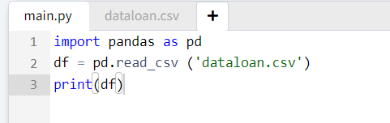

Sol -

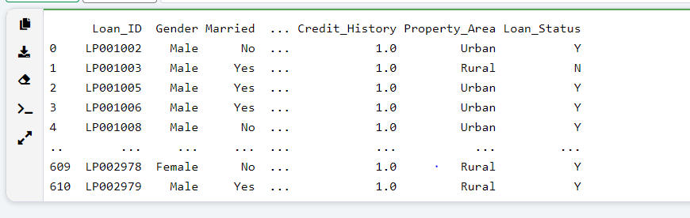

1. Print the total number of rows and columns.
2. Print number of rows only.
3. Print number of columns only.
4. Print the first 5 records.
5. Print the last 5 records.
6. Print the all non-null columns using info().
7. Print all column names.
8. Print all datatypes of respective column names.
9. Print the descriptive statistics of data frame.
10. Print the sum of NAN values.
11. Print and access only the column names like Education and Self_Employed.
12. Print and access upto second index position.
13. Rename the column gender to gender_status.